Introduction
The forecasting of student academic performance has become a prominent area of interest in the field of education. Although it is widely believed that learning outcomes improve both teaching and learning processes, predicting student success remains an underexplored area. A review of studies conducted between 2010 and November 2020 was performed to offer a thorough overview of the intelligent methods used to forecast student performance, with academic success being specifically measured through student learning outcomes (Namoun & Alshanqiti, 2021).
The second part discusses the levels of measurement in data analytics, classifying the data into categories such as Nominal, Ordinal, and Interval/Ratio. The second part also covers the four different data analytics types such as Descriptive, Diagnostic, Predictive, Prescriptive. The third part discusses the three business problems in the context of the education industry. Lastly the fourth part discusses the conclusion.

2. Data Analytics
Data analytics in higher education provides valuable opportunities to examine, understand, and model teaching and learning processes. Consequently, this has led to the emergence of closely related concepts such as Learning Analytics (LA), Academic Analytics (AA), and Educational Data Mining (EDM), where the outcomes of one can serve as inputs for the others (Nguyen et al., 2020).

2.1 Types of Data
2.1.1 Nominal Data
Nominal data is a type of qualitative data that classifies variables into categories, which serve as labels or names. These categories are purely descriptive and do not carry any quantitative or numerical value. Furthermore, there is no meaningful order or hierarchy among the categories (Stevens, 2022).
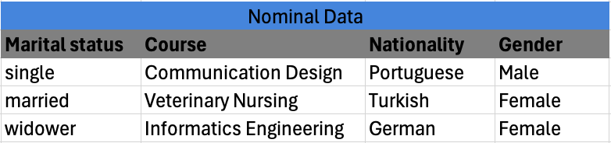
Figure 1: Nominal Variable
2.1.2 Ordinal Data
Ordinal data organizes data by introducing a specific order or ranking. For example, economic status can be categorized as ‘wealthy,’ ‘middle income,’ or ‘poor.’ However, the intervals between these categories are not clearly defined, meaning the exact differences in magnitude between them are not measurable (Hillier, 2023).
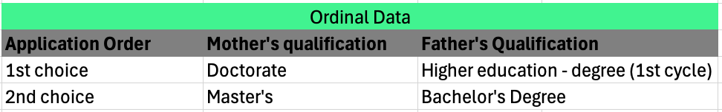
Figure 2: Ordinal Variable
2.1.3 Interval/Ratio
Interval data is a level of measurement that involves quantitative data, typically represented by numbers. It has an inherent order, like ordinal data, but with the key difference that the intervals between measurement points are equal. In contrast, ratio data is similar to interval data, but it has an absolute zero, which indicates the complete absence of the measured attribute (Jansen, 2020).
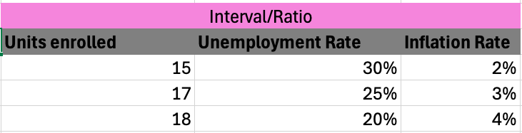
Figure 3: Interval Ratio Variable

2.2 Types of Data Analytics
Data analytics is the process of utilizing analytical tools to extract insights from datasets, which help guide decision-making. By applying data analytics, organizations can enhance decision-making, optimize operations, and boost revenue (Chen, 2024).
2.2.1 Descriptive Analytics
Descriptive analytics involves analyzing historical data to gain an understanding of past events. It focuses on collecting data, identifying patterns, and extracting insights or lessons from previous occurrences (Yasar, 2024).
2.2.2 Diagnostics Analytics
Diagnostic analytics goes beyond surface-level data to explore the underlying causes of specific events. It focuses on identifying root causes, examining correlations, and uncovering relationships between various variables (Yasar, 2024).
2.2.3 Predictive Analytics
Prescriptive analytics extends beyond forecasting future outcomes by offering specific recommendations for decision-making. It uses optimization and simulation methods to identify the most effective strategies to achieve the desired results (Yasar, 2024).
2.24 Prescriptive Analytics
Prescriptive analytics extends beyond forecasting future outcomes by offering specific recommendations for decision-making. It uses optimization and simulation methods to identify the most effective strategies to achieve the desired results (Yasar, 2024).

3. Impact of Data Analytics in the Education Industry
This section aims to identify three critical business challenges related to student performance and its effects across different contexts through the application of data analytics. By utilizing data-driven insights, educational institutions can confirm these issues and make well-informed, strategic decisions that positively impact both students and the institution.
3.1 Problem 1: Enhance Student outcomes

3.2 Early identification of At Risk Students / Predicting Student Performance
At the university level, students often abandon certain subjects they were enrolled in for the academic year. This behavior typically begins with skipping or missing lectures, which may stem from neglect or carelessness, or from struggling to understand the subject. As a result, they fall behind on the class schedule set by the professor and lose track of the course material. When students return after a period of absence, they often find themselves discouraged by their lack of understanding, which leads them to skip lectures and choose to study independently. However, some of these students may not show up for their final exams, while those who do take the exams often have high failure rates. The problem intensifies when this pattern occurs repeatedly, potentially signaling the beginning of a student’s decision to drop out of college. This is a significant concern for universities, particularly in the early years of study. College dropouts have become a widely discussed issue, with numerous analyses aimed at identifying the causes, whether they are social, family-related, organizational, or personal (M. Gascueña & Guadalupe García, 2012). Academic failure increased the likelihood of course attrition by 4.2 times. Students who failed but persisted in their studies often cited a combination of personal, situational, and institutional factors as the cause of their academic challenges. The compounded impact of academic failure on already vulnerable students contributed to the development of strong negative emotions (Ajjawi et al., 2020).
In the current educational environment, accurately forecasting academic performance remains a significant challenge. Conventional methods typically depend on limited data sources and do not fully account for the complex factors that affect student success (Bagade, 2024).
Using predictive and prescriptive analytics would be the most effective approach to thoroughly analyze variables such as 'grades,' 'ethnicity,' 'study time,' and other nominal, ordinal, interval, and ratio data. This analysis would provide various information, from determining which students might need school help to get back on their feet, and what these students could do to improve their grades. By developing models to predict study outcomes early and evaluating them using cross-validation and misclassification errors, we can determine which model achieves the best classification accuracy. This allows us to present predictive results in a way that is easily understandable for students, teachers, and academic staff (Kovačić & Green, 2010). Early identification of at-risk students in a course is crucial. Given the limitations of current academic early warning systems, developing highly accurate prediction models is essential to effectively identify these students at risk (Marbouti et al., 2016).

3.3 Improving graduation rates

3.4 Improve Student Retention Strategies
Student retention is a major concern for higher education institutions, with around 30% of students in OECD member countries withdrawing from higher education before earning their degrees (Mah, 2016). Early dropping of subjects, especially during the first year of study, can be attributed to several factors, such as difficulties in adjusting to university life, boredom, lack of interest, poor preparation, limited academic and social involvement, challenges in balancing study demands with personal responsibilities, and dissatisfaction with the course or institution. (Coates, 2014; Hobsons, 2014, as cited in Seidel & Kutieleh, 2017). This causes students to withdraw from their classes or studies.
Consequently, higher education institutions are increasingly prioritizing the collection and analysis of dynamic student data through learning analytics. This method allows them to gain a better understanding of students' experiences and enhance their ability to predict and improve learning outcomes (Ferguson, 2012; Fiaidhi, 2014; Ifenthaler, 2015; Ifenthaler et al., 2014; Long and Siemens, 2011, as cited in Mah, 2016). Moreover, digital badges are an innovative technology in education that serve to recognize learners' achievements, knowledge, skills, and competencies in both formal and informal learning environments (EDUCAUSE, 2012; Gibson et al., 2013; Ifenthaler et al., 2016, as cited in Mah, 2016). Student retention primarily concentrates on the student, which is, of course, understandable. Research in this area often seeks to test hypotheses by either investigating or clarifying the student's viewpoint. There are examples (e.g., Thomas, 2002) of studies that deviate from this approach by focusing on the perspective of the institution and examining how it impacts students. In this context, utilizing diagnostic, predictive, and prescriptive analytics proves to be an effective strategy. This approach helps identify the likely causes of student issues, recognize potential student attrition, and suggest methods to mitigate it. By examining various student data, including background (socio-economic factors), personal characteristics (age, employment history, family circumstances, etc.), prior educational experience (such as the institution attended), and living arrangements (on or off-campus), insights can be gained. Additionally, factors like the student's level of engagement, both academically and socially, are also considered in assessing the risk of student retention. (McCarthy, 2019).

4. Conclusion
In conclusion, using data analytics for educational institution can improve overall student outcomes and performance. By using various student data and analytical techniques, schools, universities, and other education institutions can gather highly valuable insights to address school problems such as student attrition, and student performance, etc. Descriptive and Diagnostic analytics are also helpful in this study but Predictive and Prescriptive analytics would be the ideal way to study student variables like ‘grades’, ‘ethnicity’, ‘study time’, to provide information on which student might need school help and what these students could do to improve their grades. It is crucial to identify at risk students as early as possible.

